Kim Sae-byeol
Manga Character Profile Dossier · BAN240

Course: BAN240 | Document Type: Character Sheet | Date: June 6, 2026
Character: Kim Sae-byeol | Role: The Aesthetic Eye | Prepared by: Stephen
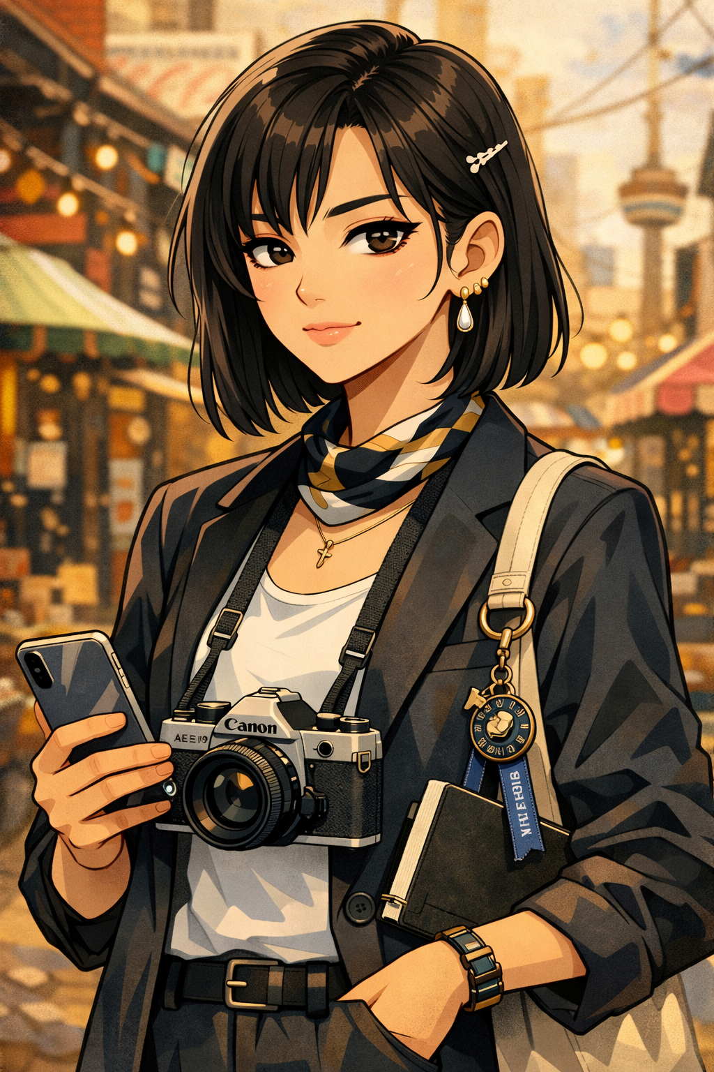
Section 01 Biographical Overview

Sae-byeol — her name means "new star" in Korean, a fact she finds either poetic or embarrassing depending on the day — is a 22-year-old Korean international student studying Fashion Communication. She arrived in Toronto with a film camera, four suitcases, and a carefully curated vision of who she was going to be. She is still constructing that person, with more precision and more doubt than she lets on.
She came from Daegu, not Seoul — a distinction she makes clear when anyone assumes otherwise. Daegu has its own aesthetic, its own pace, its own textures, and she carries them in the way she sees things: slower, more deliberate, slightly warmer than the Seoul-student default.

"She sees the world as a series of frames. The question her arc asks is: what happens when she lets herself be in the picture instead of just behind it."
— Character Narrative Function Note

Her emotional complexity lives in the gap between what she presents and what she actually experiences. She is extremely good at curating a version of herself — her visual identity is flawless — and she is learning, slowly, that the people worth knowing are not fooled by curation.
Section 02 Demographics & Basic Information

Field | Detail
Full Name | Kim Sae-byeol
Goes By | Sae-byeol (insists on full name); occasionally "Stella" with non-Korean speakers who struggle — she accepts this with visible resignation
Age | 22
Birthday | April 5
Gender | Female
Pronouns | She/Her
Ethnicity | Korean (Daegu, North Gyeongsang Province)
Hometown | Daegu, South Korea
Current City | Toronto, Ontario, Canada — Kensington Market area
Living Situation | Lives alone in a small studio apartment in the Kensington Market area — expensive for her budget, but she considers the neighbourhood's visual texture worth the financial stress; the apartment is arranged with extreme aesthetic intentionality
Immigration Status | International student visa
Languages | Korean (native) · English (highly proficient; precise, slightly formal; excellent written English; speaks slowly in English when choosing words carefully) · French (intermediate, self-studying; uses Duolingo but will deny it)
Occupation | Full-time undergraduate student; occasional freelance photography for student publications and small local brands; sells vintage finds at a Kensington pop-up once a month
University | Toronto Metropolitan University (TMU)
Program | Fashion Communication (BA)
Year | 3rd Year

Section 03 Physical Appearance & Manga Portrait Description

Physical Profile

Attribute | Description
Height | 5'6"
Build | Slender and composed — she occupies space deliberately, without taking too much or too little; her stillness reads as confidence even when she is uncertain
Hair | Dark brown, shoulder-length, blunt cut she maintains herself; occasionally worn half-up with a single barrette; when she changes her hair, the ensemble notices before she announces it
Eyes | Slightly upturned, very dark, with the specific quality of someone who is cataloguing details in real time; rarely blinks at what surprises her; her most expressive feature is her eyebrows, which do significant communicative work
Skin Tone | Cool light-medium with a slight golden undertone; carefully maintained; she does not discuss her skincare routine except with people she trusts, at which point she discusses it at length
Typical Outfit | Thoughtfully assembled vintage-adjacent looks: structured blazers, wide-leg trousers, muted or monochrome palette punctuated by one deliberate accent — a silk scarf, a specific earring, an unexpected bag; she never looks effortless, she looks precise
Accessories | A 35mm film camera worn around the neck most days — it is not a prop; she uses it constantly; vintage gold earrings (mismatch is intentional); a small notebook in her breast pocket; no phone case (the bare phone is a design choice)

Manga Art Style Notes

◆ Artist Direction
• Framing panels: Sae-byeol's point-of-view panels are drawn as if through a viewfinder — slight vignette at the edges, composition-conscious cropping. The reader sees what she sees, and it is always more considered than the standard panel.
• The camera: Always drawn accurately and with detail. It is an extension of her hand, not an accessory. She is most herself when she is behind it — and this is the problem.
• Unguarded moments: Depicted as slightly out-of-focus, as if she has briefly stepped in front of the lens herself. Warmer line weight, slightly softer shading. These are the moments the reader cherishes.
• The eyebrow economy: She communicates disapproval, surprise, and interest primarily through eyebrow movement. One raised brow = doubt. Both raised = genuine surprise (rare). One lowered = dangerous attention. The manga uses these as visual shorthand.
• Daegu vs. Seoul moments: When she corrects someone about Daegu, the panel gives her a brief internal glow — pride she does not entirely show on her face. Her hometown is a quiet but genuine source of identity.
• Vintage-find panels: When she discovers something in a thrift shop or market stall, the lighting brightens and a small sparkle detail appears — the only "shoujo" visual effect she is allowed, and it is entirely earned.

Section 04 Personality & Quirks

Sae-byeol is precise, observant, occasionally cutting, and secretly quite soft. The precision is not unkindness — it is how she shows respect; she pays attention to you well enough to know exactly what you are doing wrong and why, and she considers this care.
- Has a strong and vocally held opinion about fonts, menus, signage, packaging, and all visual communication she encounters in daily life; restaurants are pre-judged by their menu design before anyone has ordered.
- Takes photographs constantly — not with her phone, with film; the camera is loaded; she will use the whole roll in a day if the light is right.
- Speaks more slowly than her thoughts move; she is choosing words with something close to typographic intention; do not rush her.
- Maintains an elaborate system for vintage clothing care — temperature, storage, the specific hangers she uses — that she will explain if asked and that no one else in the apartment block understands.
- Corrects herself mid-sentence when she uses a word imprecisely; does the same to others, gently, and almost always correctly.
- Gets quietly competitive about visual things: who saw the better angle, who noticed the detail, who composed the better frame; this is her version of trash talk.
- Does not hug first, but returns hugs fully and for longer than expected; physical warmth is available once earned.

◆ Character Note — Behind the Lens
The camera is not avoidance — but it is also not not avoidance. She can be fully present through a lens in a way she cannot always manage without one. Her arc asks her to put the camera down and stand in the frame: to be seen, unmediated, by people who have seen her photographs and want to know the person who takes them.

Section 05 Hobbies & Interests

# | Hobby | Notes
1 | Film Photography | Uses a 35mm Canon AE-1; shoots primarily street, portrait (with permission), and found-object still life; develops her own film at a community darkroom near campus; considers digital photography a different and lesser art form (controversial, holds this view openly)
2 | Vintage & Thrift Sourcing | Visits Kensington Market, Value Village, and estate sales; her eye for quality and provenance is exceptional; sells selected finds at a monthly pop-up to offset her rent
3 | Fashion Illustration | Her most private creative practice; keeps a sketchbook she rarely shows; the illustrations are technically precise and emotionally honest in a way her photographs are not
4 | French New Wave & Korean Cinema | Park Chan-wook, Bong Joon-ho, Godard, Varda — curates personal film lists by mood and season; considers film literacy a form of cultural fluency
5 | K-Indie Music & Playlist Curation | Ditto, Hyukoh, Jannabi, Leenalchi — specific taste, not mainstream; considers playlist order a compositional act
6 | Journaling (Visual) | Mixed-media journal — photographs, ticket stubs, pressed flowers, handwritten observations; this is her real portfolio and she would never show it
7 | Coffee (Serious) | Has strong opinions about extraction and milk ratios; frequents two cafes in Kensington; knows both baristas by name; considers instant coffee a moral failing

Section 06 Sports Profile

Category | Sport & Detail
Primary Sport (Former Participatory) | Figure skating — trained through age 16 in Daegu; quit due to a wrist injury; watches Grand Prix events with sustained nostalgia and specific technical criticism; her knowledge of jump nomenclature is exact
Primary Sport (Current Participatory) | None formal — walks everywhere in Toronto as a combination of commute and photography expedition; considers this sufficient
Secondary Sport (Fan) | Follows Korean national figure skating; also has a mild interest in the Tour de France aesthetics (specifically the mountain stages, which she has photographed from television)
Anime Sports Influence | Yuri!!! on Ice — watched primarily for the aesthetic and the costume design; stayed for the character study; has strong opinions about the animation quality in specific sequences

Section 07 Fandoms

Fandom | Description & Intensity
Park Chan-wook | Deep and studied; considers his visual language the most precise in contemporary Korean cinema; has written a personal essay (unsubmitted, in her visual journal) about his use of colour
Hyukoh | Primary music fandom; considers their debut album a perfect aesthetic object; listens to Oh Hyuk's solo work with equal devotion
Kensington Market Community | Not a conventional fandom — the neighbourhood is her creative infrastructure; its chaos and layering are what she photographs most; she would be devastated to lose it
Ditto (K-Indie) | Discovered during her first week in Toronto; has followed every project since; the music carries a specific texture she has never been able to fully articulate
Vintage Fashion Collectors Online | Participates in several niche communities for specific eras of Japanese and Korean fashion; her expertise is genuinely respected; no one there knows her real name
Yuri!!! on Ice | Watches for the visual direction and the costume design specifically; rewatches the Grand Prix Final episode for the choreography choices; this fandom is personal and unannounced

Section 08 Commute & Daily Life

The Commute

Leg | Detail
Home Base | Kensington Market — College Street corridor
Route | Walks to TMU most days (25–30 minutes); takes the TTC streetcar on the College route when it is raining or very cold; considers the walk her best daily photography window
Duration | 25–30 minutes walking; 15 minutes by streetcar
Commute Mood | No music during the walk — she needs to hear the city; film camera loaded and accessible; has burned through a roll of 36 exposures during a single morning walk on at least three occasions
Signature Move | Stops mid-sidewalk to photograph something with no warning; people who know her learn to stop moving when she stops; people who do not know her walk into her
Transit Pet Peeve | Streetcar delays; not because of the time lost, but because the streetcar route runs through her best photography zone and delay means standing still without interesting subjects

On-Campus Routine
- Arrives slightly late to everything — never very late, but the 3-minute delay is consistent; it is not disrespect, it is the photography stop she made on the way.
- Sits where the light is best, not where a seat is available; has been known to move seats twice in the first five minutes of a lecture.
- Reviews her contact sheets (film proofs) during breaks instead of her phone; her phone has relatively few apps and is used primarily for email.
Weekly Rhythm

Time | Activity
Weekday mornings | Walk to campus with camera; the walk is the most important part of the day
Weekday afternoons | Lectures, studio critique sessions; Fashion Communication involves significant peer review and she is very direct in critique, which people learn to appreciate
Weekday evenings | Darkroom sessions at the community lab (twice weekly); vintage clothing care; French study (Duolingo, again, denied)
Saturday | Kensington pop-up market (one Saturday per month); otherwise: thrift sourcing, photography, solo film afternoon at the TIFF Lightbox or Hot Docs Cinema
Sunday | Video call with her parents in Daegu; her mother asks about food and friends; she answers with photographs instead of words, and her mother understands

Section 09 Character Role & Narrative Function

Sae-byeol is the ensemble's eye — the character who renders the world of the story visible in a specific, curated way. Her perspective is literally different: she sees framing, she sees light, she sees what everyone else has stopped noticing.
Narrative Arc
Her arc is the movement from observer to participant — from the person who holds the camera to the person who lets someone else hold it. The story does not require her to stop photographing. It requires her to allow herself to be in the frame.

"Her most powerful scene is not the photograph she takes. It is the one she does not — because she puts the camera down to actually be there."
— BAN240 Character Narrative Notes

Ensemble Role Summary

Function | How It Manifests
The Eye | Frames and renders the world of the story; her perspective is the reader's visual education
Aesthetic Counterpoint | Her precision and standards push other characters toward more intentional choices — sometimes frustratingly
Emotional Depth Carrier | Her arc is the subtlest in the ensemble; small visual details signal her movement; readers who are paying attention know before she does
Cultural Specificity | Brings Daegu aesthetic and Korean indie-culture texture; refuses to collapse into a generalized "Korean" identity and the narrative honours this

Kim Sae-byeol — BAN240 Manga Character Sheet · Toronto Metropolitan University · Prepared June 6, 2026
Document prepared by Stephen · BAN240 Character Profile Dossier Series

